Tata Consultancy Services | 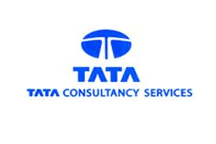
AMAZON, CHENNAI | 
IBM India Private Limited, | 
ARICENT, Chennai | 
Accenture | 
GOFRUGAL, CHENNAI | 
IVTL Infoview Technologies Private Limited | 
Renault Nissan Technology & Business Centre India | 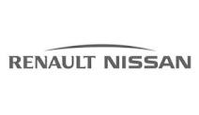
Cognizant Technology Solutions | 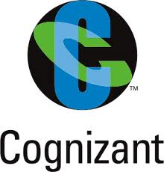
INFOSYS | 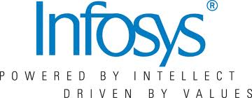
American Megatrends India Private Limited | 
ZOHO, Chennai | 
Vuram Technology Solutions, | 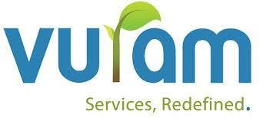
Hexaware Technologies Limited | 
Thirdware, Chennai | 
Aspire Systems | 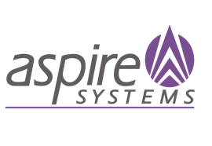
Jasmin Infotech | 
WIPRO Technologies | 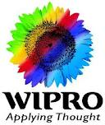
Brakes India Limited | 
Solartis | 
Vernalis | 
MAVERIC | 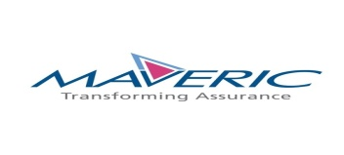
Hi Tech Arai Limited | 
Suresoft Systems Private Limited | 
SRM Technologies Private Limited | 
Virtusa India Private Limited | 
Technip India Limited | 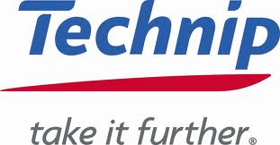
TVS Tyres, Chennai | 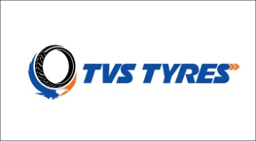
Wheels India Limited | 
Indus Teqsite Private Limited | 
TVS Sundaram Fastners, Madurai | 
Soft Square, Chennai | 
Glenwood systems | 
Clustrex, Chennai | 
Sun Pressing Private Limited | 
V-DART Software Services Pvt Ltd | 
CSS corp | 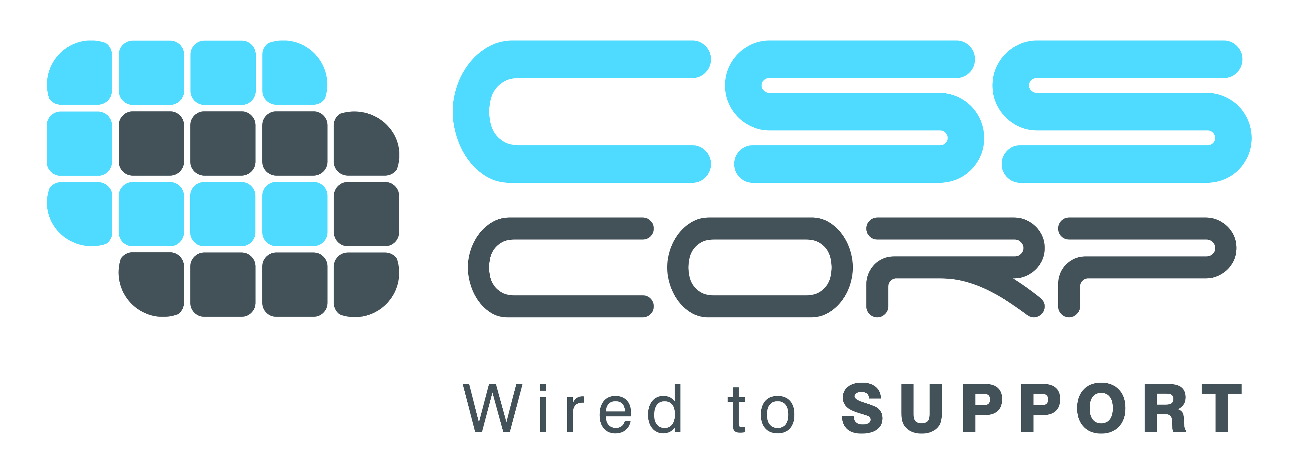
Mobius | 
Temenos India Private Limited | 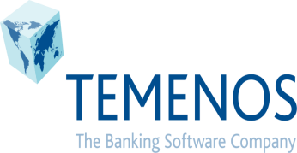
VEE Technologies, Chennai | 
Apptivo Software Private Ltd | 
LADDER SURVEY | 
Sutherland Global Services | 
Cogzidel Technologies | 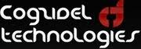
TVS Infotech | 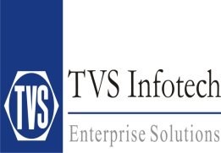
Amogaa, Madarai | 
Veryx Techologies | 
CADD Center, Chennai | 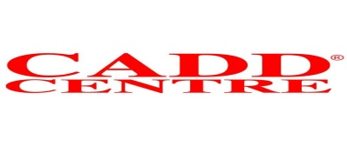
Verizon Data Services India, | 
Sanmar Engineering Technologies Limited, | 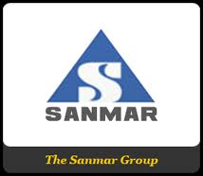
SellerGro, Chennai | 
CVIAC Consulting pvt. ltd., Chennai | 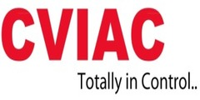
Prodex Technologies | 
Avalon Technologies pvt. Ltd., Chennai | 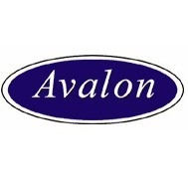
NFN Labs, Chennai | 
Sysarc Infomatrix, chennai | 
Flutura Business Solutions, chennai | 
Saint-Gobain Glass India | 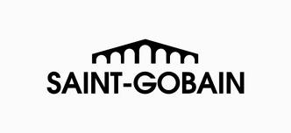
Elgi Equipments Limited | 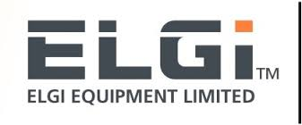
Larson And Tubro Engineering And Construction Limited | 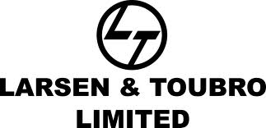
Madras Cements Limited | 
Coromandel Cements | 
Thai Summit Neel Auto Components | 
Good Through Software Solution, | 
Blue Whale Solutions, | 
Congruent Solutions Private Limited | 
FSS | 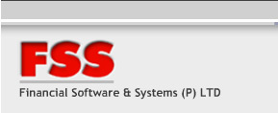
Pacific Web Technology | 
SPIC | 
i- Horse Technologies | 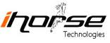
Appasamy Associates, Chennai | 
Elysium Technologies, Madurai | 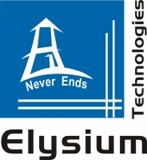
Zealous Services, Chennai | 
Syntel Limited | 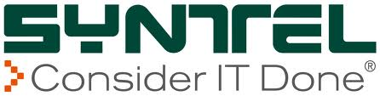
Castwel auto parts Private Limited | 
i-Max Industrial Automation Technologies | 
SAIPEM Project | 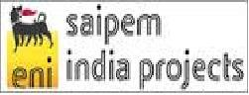
Sakthi Auto Components Private Limited | 
Hyundai Motor India Limited | 
EP Software Technologies | 
Maxwell Services | 
COLLABERA, Chennai | 
Trend Instrumentation And Automation Private Limited | 
Input Solution | 

